Be careful to

* Don't run any script using selenium multiple times at the same time. It fucks things up (potentially but not always)
* No guarantees about any other way of running scripts with selenium except right from command line using python3
* If things get messed up and stop working, restart your computer… I think sometimes multiple processes with selenium get running if you quit a program the wrong way and this really screws things up

1. First, get the latest changes from github, from my branch
2. To install chromedriver, do brew cask install chromedriver
   1. If you don't have homebrew, install homebrew first (google it, it's easy)
   2. If this fails because there's already a chromedriver there, do mv /usr/local/bin/chromedriver /usr/local/bin/chromedriver.bak
3. Type the command **which chromedriver** into terminal. You should get something reasonable. If you then just type **chromedriver**, it may say something like "killed 9", or refuse to run. If this happens
   1. Now go to system preferences -> security and allow it to run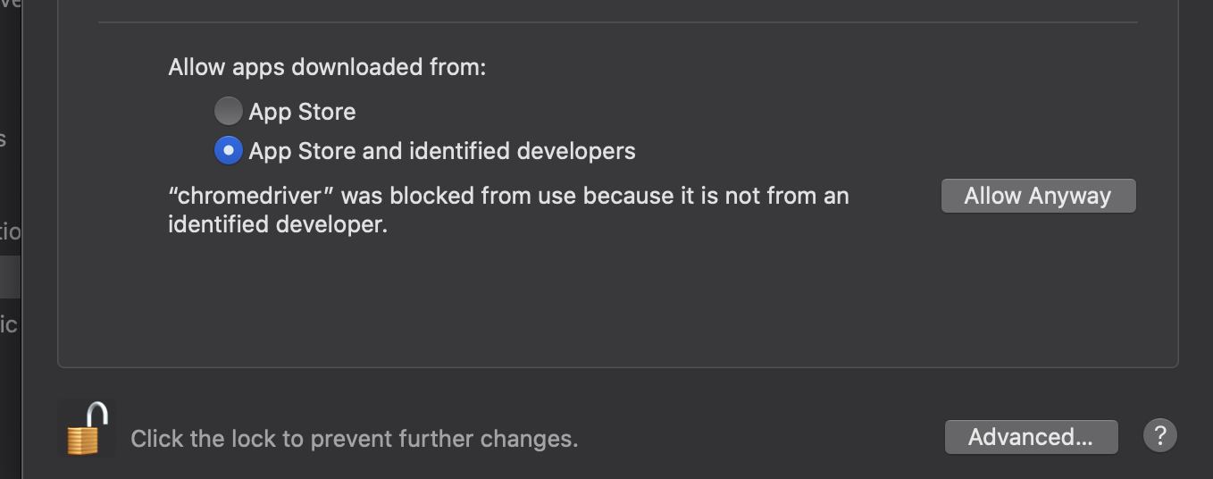
4. There's just about zero chance this is going to work with Jupyter notebook and I'm not going to spend too much time trying. It doesn't play nice with Eclipse either… at this point, go to the "scripts" folder in our repo and run python3 ex2.py, and you should see something itneresting

Super basic:

* Try running it in python3  
    
  from selenium import webdriver; driver=webdriver.Chrome()